SWITCH MIGRATION / LIF FAILOVER
NetApp Cluster Mode

Gunasekar Venkatraman

August- 2015

This document describes the Step by step procedure for NetApp cluster mode filer switch migration or LIF Failover

Prework:

- Check the cluster and nodes health status

Login to cluster console using user “admin” and run “system health status show” and “cluster show”

Cluster show command output shows the node names and their health status.

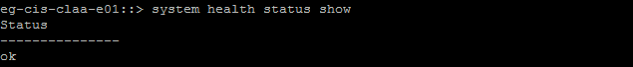

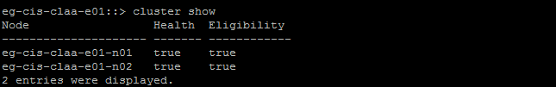

- Current Network Configuration

- Check the port configuration

Run “network port show” and it displays the following

Node name
Port name
Role name -- Data/Mgmt/Cluster LIF assigned
Link -- Link status up/down
MTU -- MTU size of the LIF
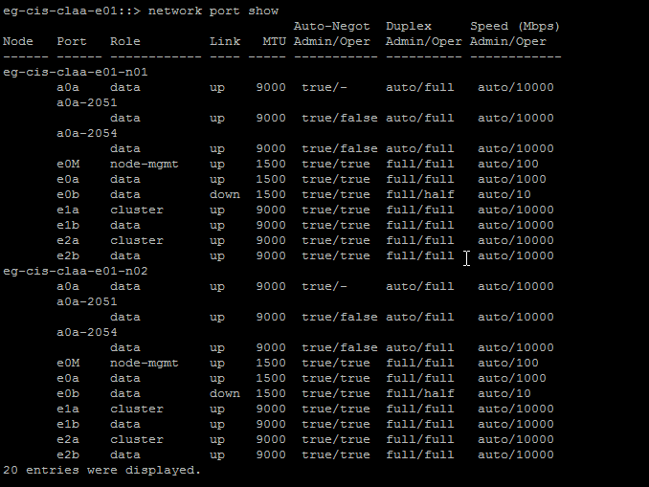

- Check the current network configuration

Run “network interface show” or “ net int show”

The below output will be displayed

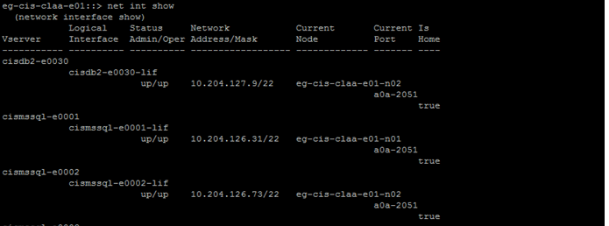
.
.
.
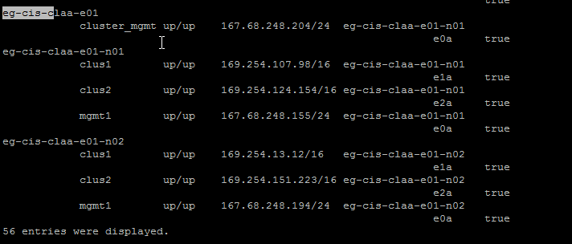

- Vserver – The vserver that owns the LIF
- Logical Interface – LIF name
- Status -- Status of LIF (up/down)
- Network Address/Mask – IP configuration
- Current Node – The node owns the LIF
- Is Home -- true/false –
True means the current node is the parent node for the LIF
False means the current node is not the parent node and we can mention as Foreign LIF.

- Check the Failover Groups

Run “network interface failover-groups show”

The output displays the failover group name and its member.

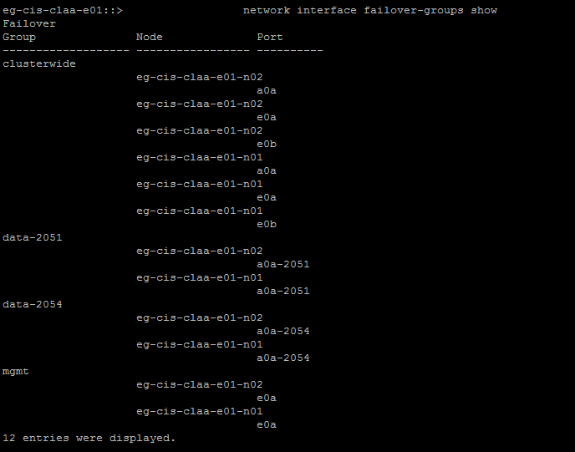

- Check the Failover Policy information

Run “network interface show –role data –failover” to see the data lif failover policy details.

The output shows the

Failover Policy name
Failover Group name
Failover Targets: Normally it has the home node and the port in first and then the partner/other failover node and port.

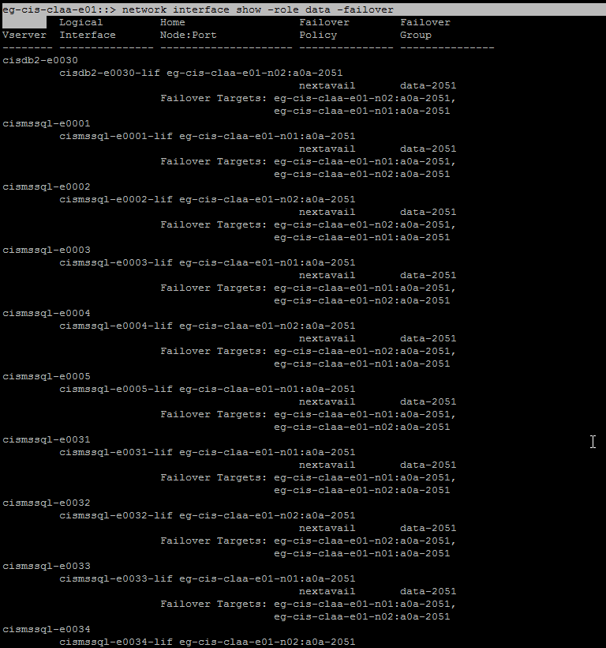

Run “network interface show -lif * -role cluster-mgmt” to see the cluster failover details

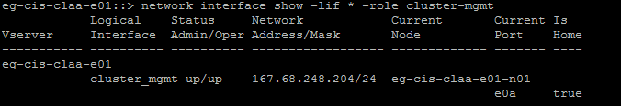

- Check the IFGRP/VIF status

Run “system node run -node eg-cis-claa-e01-n01 -command ifgrp status”

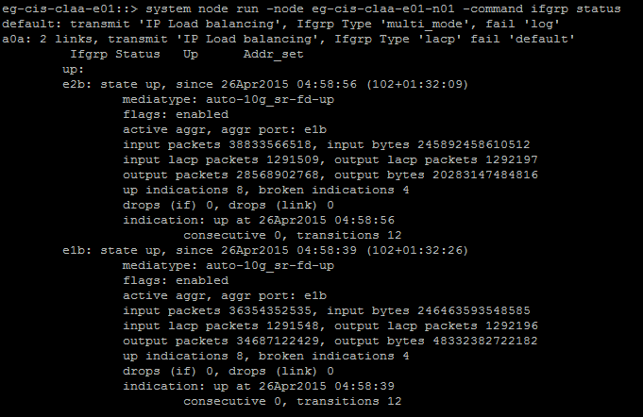

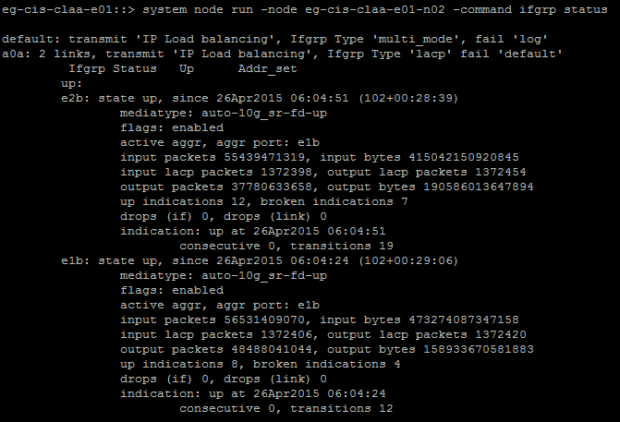

- Check the network interface based on protocol (NFS/ISCSI/CIFS)

Run “network interface show -data-protocol nfs|iscsi|fcp -curr-node eg-cis-claa-e01-n01”

eg-cis-claa-e01::> network interface show -data-protocol nfs|iscsi|fcp -curr-node eg-cis-claa-e01-n01
Logical Status Network Current Current Is
Vserver Interface Admin/Oper Address/Mask Node Port Home
----------- ---------- ---------- ------------------ ------------- ------- ----
cismssql-e0001
cismssql-e0001-lif
up/up 10.204.126.31/22 eg-cis-claa-e01-n01
a0a-2051
true
cismssql-e0003
cismssql-e0003-lif
up/up 10.204.126.135/22 eg-cis-claa-e01-n01
a0a-2051
true
cismssql-e0005
cismssql-e0005-lif
up/up 10.204.126.137/22 eg-cis-claa-e01-n01
a0a-2051
true
cismssql-e0031
cismssql-e0031-lif
up/up 10.204.126.112/22 eg-cis-claa-e01-n01
a0a-2051
true
cismssql-e0033
cismssql-e0033-lif
up/up 10.204.126.114/22 eg-cis-claa-e01-n01
a0a-2051
true
cismssql-e0035
cismssql-e0035-lif
up/up 10.204.126.140/22 eg-cis-claa-e01-n01
a0a-2051
true
cismssql-e0037
cismssql-e0037-lif
up/up 10.204.126.150/22 eg-cis-claa-e01-n01
a0a-2051
true
cismysql-e0031
cismysql-e0031-lif
up/up 10.204.126.116/22 eg-cis-claa-e01-n01
a0a-2051
true

Logical Status Network Current Current Is
Vserver Interface Admin/Oper Address/Mask Node Port Home
----------- ---------- ---------- ------------------ ------------- ------- ----
cisoracle-e0001
cisoracle-e0001-lif
up/up 10.204.126.74/22 eg-cis-claa-e01-n01
a0a-2051
true
cisoracle-e0003
cisoracle-e0003-lif
up/up 10.204.126.80/22 eg-cis-claa-e01-n01
a0a-2051
true
cisoracle-e0005
cisoracle-e0005-lif
up/up 10.204.126.81/22 eg-cis-claa-e01-n01
a0a-2051
true
cisoracle-e0007
cisoracle-e0007-lif
up/up 10.204.126.86/22 eg-cis-claa-e01-n01
a0a-2051
true
cisoracle-e0009
cisoracle-e0009-lif
up/up 10.204.126.88/22 eg-cis-claa-e01-n01
a0a-2051
true
cisoracle-e0011
cisoracle-e0011-lif
up/up 10.204.126.90/22 eg-cis-claa-e01-n01
a0a-2051
true
cisoracle-e0013
cisoracle-e0013-lif
up/up 10.204.126.92/22 eg-cis-claa-e01-n01
a0a-2051
true
cisoracle-e0015
cisoracle-e0015-lif
up/up 10.204.126.94/22 eg-cis-claa-e01-n01
a0a-2051
true

Logical Status Network Current Current Is
Vserver Interface Admin/Oper Address/Mask Node Port Home
----------- ---------- ---------- ------------------ ------------- ------- ----
cisoracle-e0017
cisoracle-e0017-lif
up/up 10.204.126.96/22 eg-cis-claa-e01-n01
a0a-2051
true
cisoracle-e0019
cisoracle-e0019-lif
up/up 10.204.126.98/22 eg-cis-claa-e01-n01
a0a-2051
true
cisoracle-e0021
cisoracle-e0021-lif
up/up 10.204.126.100/22 eg-cis-claa-e01-n01
a0a-2051
true
cisoracle-e0023
cisoracle-e0023-lif
up/up 10.204.126.102/22 eg-cis-claa-e01-n01
a0a-2051
true
cisoracle-e0025
cisoracle-e0025-lif
up/up 10.204.126.104/22 eg-cis-claa-e01-n01
a0a-2051
true
cisoracle-e0031
cisoracle-e0031-lif
up/up 10.204.126.110/22 eg-cis-claa-e01-n01
a0a-2051
true
cisoracle-e0033
cisoracle-e0033-lif
up/up 10.204.126.180/22 eg-cis-claa-e01-n01
a0a-2051
true
cisoracle-e0035
cisoracle-e0035-lif
up/up 10.204.126.255/22 eg-cis-claa-e01-n01
a0a-2051
true
24 entries were displayed.

During Migration:

- Checks the network interfaces based on protocol on Node 1 and note the number of entries at the end of output.

Run “network interface show -data-protocol nfs|iscsi|fcp -curr-node eg-cis-claa-e01-n01”

eg-cis-claa-e01::> network interface show -data-protocol nfs|iscsi|fcp -curr-node eg-cis-claa-e01-n01
Logical Status Network Current Current Is
Vserver Interface Admin/Oper Address/Mask Node Port Home
----------- ---------- ---------- ------------------ ------------- ------- ----
cismssql-e0001
cismssql-e0001-lif
up/up 10.204.126.31/22 eg-cis-claa-e01-n01
a0a-2051
true
cismssql-e0003
cismssql-e0003-lif
up/up 10.204.126.135/22 eg-cis-claa-e01-n01
a0a-2051
true
cismssql-e0005
cismssql-e0005-lif
up/up 10.204.126.137/22 eg-cis-claa-e01-n01
a0a-2051
true
cismssql-e0031
cismssql-e0031-lif
up/up 10.204.126.112/22 eg-cis-claa-e01-n01
a0a-2051
true
cismssql-e0033
cismssql-e0033-lif
up/up 10.204.126.114/22 eg-cis-claa-e01-n01
a0a-2051
true
cismssql-e0035
cismssql-e0035-lif
up/up 10.204.126.140/22 eg-cis-claa-e01-n01
a0a-2051
true
cismssql-e0037
cismssql-e0037-lif
up/up 10.204.126.150/22 eg-cis-claa-e01-n01
a0a-2051
true
cismysql-e0031
cismysql-e0031-lif
up/up 10.204.126.116/22 eg-cis-claa-e01-n01
a0a-2051
true

Logical Status Network Current Current Is
Vserver Interface Admin/Oper Address/Mask Node Port Home
----------- ---------- ---------- ------------------ ------------- ------- ----
cisoracle-e0001
cisoracle-e0001-lif
up/up 10.204.126.74/22 eg-cis-claa-e01-n01
a0a-2051
true
cisoracle-e0003
cisoracle-e0003-lif
up/up 10.204.126.80/22 eg-cis-claa-e01-n01
a0a-2051
true
cisoracle-e0005
cisoracle-e0005-lif
up/up 10.204.126.81/22 eg-cis-claa-e01-n01
a0a-2051
true
cisoracle-e0007
cisoracle-e0007-lif
up/up 10.204.126.86/22 eg-cis-claa-e01-n01
a0a-2051
true
cisoracle-e0009
cisoracle-e0009-lif
up/up 10.204.126.88/22 eg-cis-claa-e01-n01
a0a-2051
true
cisoracle-e0011
cisoracle-e0011-lif
up/up 10.204.126.90/22 eg-cis-claa-e01-n01
a0a-2051
true
cisoracle-e0013
cisoracle-e0013-lif
up/up 10.204.126.92/22 eg-cis-claa-e01-n01
a0a-2051
true
cisoracle-e0015
cisoracle-e0015-lif
up/up 10.204.126.94/22 eg-cis-claa-e01-n01
a0a-2051
true

Logical Status Network Current Current Is
Vserver Interface Admin/Oper Address/Mask Node Port Home
----------- ---------- ---------- ------------------ ------------- ------- ----
cisoracle-e0017
cisoracle-e0017-lif
up/up 10.204.126.96/22 eg-cis-claa-e01-n01
a0a-2051
true
cisoracle-e0019
cisoracle-e0019-lif
up/up 10.204.126.98/22 eg-cis-claa-e01-n01
a0a-2051
true
cisoracle-e0021
cisoracle-e0021-lif
up/up 10.204.126.100/22 eg-cis-claa-e01-n01
a0a-2051
true
cisoracle-e0023
cisoracle-e0023-lif
up/up 10.204.126.102/22 eg-cis-claa-e01-n01
a0a-2051
true
cisoracle-e0025
cisoracle-e0025-lif
up/up 10.204.126.104/22 eg-cis-claa-e01-n01
a0a-2051
true
cisoracle-e0031
cisoracle-e0031-lif
up/up 10.204.126.110/22 eg-cis-claa-e01-n01
a0a-2051
true
cisoracle-e0033
cisoracle-e0033-lif
up/up 10.204.126.180/22 eg-cis-claa-e01-n01
a0a-2051
true
cisoracle-e0035
cisoracle-e0035-lif
up/up 10.204.126.255/22 eg-cis-claa-e01-n01
a0a-2051
true
24 entries were displayed.

eg-cis-claa-e01::>

- Checks the network interfaces based on protocol on Node 2 and note the number of entries at the end of output.

Run “network interface show -data-protocol nfs|iscsi|fcp -curr-node eg-cis-claa-e01-n02”

eg-cis-claa-e01::> network interface show -data-protocol nfs|iscsi|fcp -curr-node eg-cis-claa-e01-n02
Logical Status Network Current Current Is
Vserver Interface Admin/Oper Address/Mask Node Port Home
----------- ---------- ---------- ------------------ ------------- ------- ----
cisdb2-e0030
cisdb2-e0030-lif
up/up 10.204.127.9/22 eg-cis-claa-e01-n02
a0a-2051
true
cismssql-e0002
cismssql-e0002-lif
up/up 10.204.126.73/22 eg-cis-claa-e01-n02
a0a-2051
true
cismssql-e0004
cismssql-e0004-lif
up/up 10.204.126.136/22 eg-cis-claa-e01-n02
a0a-2051
true
cismssql-e0032
cismssql-e0032-lif
up/up 10.204.126.113/22 eg-cis-claa-e01-n02
a0a-2051
true
cismssql-e0034
cismssql-e0034-lif
up/up 10.204.126.115/22 eg-cis-claa-e01-n02
a0a-2051
true
cismssql-e0036
cismssql-e0036-lif
up/up 10.204.126.141/22 eg-cis-claa-e01-n02
a0a-2051
true
cismssql-e0038
cismssql-e0038-lif
up/up 10.204.126.151/22 eg-cis-claa-e01-n02
a0a-2051
true
cismysql-e0032
cismysql-e0032-lif
up/up 10.204.126.117/22 eg-cis-claa-e01-n02
a0a-2051
true

Logical Status Network Current Current Is
Vserver Interface Admin/Oper Address/Mask Node Port Home
----------- ---------- ---------- ------------------ ------------- ------- ----
cisoracle-e0002
cisoracle-e0002-lif
up/up 10.204.126.83/22 eg-cis-claa-e01-n02
a0a-2051
true
cisoracle-e0004
cisoracle-e0004-lif
up/up 10.204.126.84/22 eg-cis-claa-e01-n02
a0a-2051
true
cisoracle-e0006
cisoracle-e0006-lif
up/up 10.204.126.85/22 eg-cis-claa-e01-n02
a0a-2051
true
cisoracle-e0008
cisoracle-e0008-lif
up/up 10.204.126.87/22 eg-cis-claa-e01-n02
a0a-2051
true
cisoracle-e0010
cisoracle-e0010-lif
up/up 10.204.126.89/22 eg-cis-claa-e01-n02
a0a-2051
true
cisoracle-e0012
cisoracle-e0012-lif
up/up 10.204.126.91/22 eg-cis-claa-e01-n02
a0a-2051
true
cisoracle-e0014
cisoracle-e0014-lif
up/up 10.204.126.93/22 eg-cis-claa-e01-n02
a0a-2051
true
cisoracle-e0016
cisoracle-e0016-lif
up/up 10.204.126.95/22 eg-cis-claa-e01-n02
a0a-2051
true

Logical Status Network Current Current Is
Vserver Interface Admin/Oper Address/Mask Node Port Home
----------- ---------- ---------- ------------------ ------------- ------- ----
cisoracle-e0018
cisoracle-e0018-lif
up/up 10.204.126.97/22 eg-cis-claa-e01-n02
a0a-2051
true
cisoracle-e0020
cisoracle-e0020-lif
up/up 10.204.126.99/22 eg-cis-claa-e01-n02
a0a-2051
true
cisoracle-e0022
cisoracle-e0022-lif
up/up 10.204.126.101/22 eg-cis-claa-e01-n02
a0a-2051
true
cisoracle-e0024
cisoracle-e0024-lif
up/up 10.204.126.103/22 eg-cis-claa-e01-n02
a0a-2051
true
cisoracle-e0026
cisoracle-e0026-lif
up/up 10.204.126.105/22 eg-cis-claa-e01-n02
a0a-2051
true
cisoracle-e0028
cisoracle-e0028-lif
up/up 10.204.131.17/27 eg-cis-claa-e01-n02
a0a-2054
true
cisoracle-e0032
cisoracle-e0032-lif
up/up 10.204.126.111/22 eg-cis-claa-e01-n02
a0a-2051
true
cisoracle-e0034
cisoracle-e0034-lif
up/up 10.204.126.181/22 eg-cis-claa-e01-n02
a0a-2051
true

Logical Status Network Current Current Is
Vserver Interface Admin/Oper Address/Mask Node Port Home
----------- ---------- ---------- ------------------ ------------- ------- ----
cisoracle-e0036
cisoracle-e0036-lif
up/up 10.204.127.0/22 eg-cis-claa-e01-n02
a0a-2051
true
25 entries were displayed.

eg-cis-claa-e01::>

- Check the IFGRP/VIF status.

Run “system node run -node eg-cis-claa-e01-n01 -command ifgrp status”

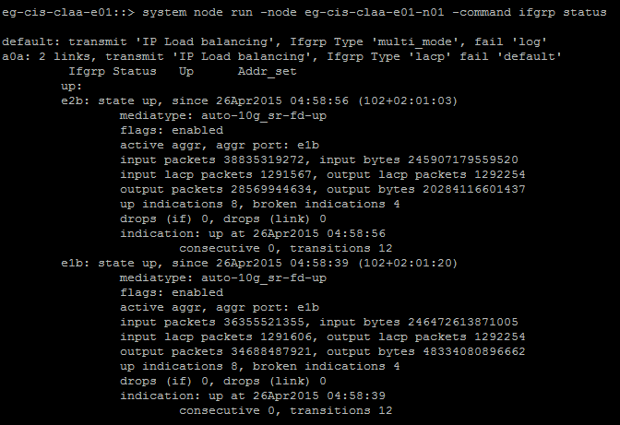

- LIF migration from Node 1 to Node 2.

Run “network interface migrate-all –node eg-cis-claa-e01-n01”

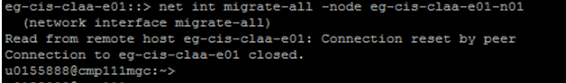

- Check the network interface based on protocol on Node 1.

Run “network interface show -data-protocol nfs|iscsi|fcp -curr-node eg-cis-claa-e01-n01”

It should show the below line “There are no entries matching your query”

- Check the Network Interface LIF status in failed over node , Node 2 .

The output shows the more entries as it has failed over LIFs and the value Home --- False indicates the failover LIFs.

eg-cis-claa-e01::> network interface show -data-protocol nfs|iscsi|fcp -curr-node eg-cis-claa-e01-n02
Logical Status Network Current Current Is
Vserver Interface Admin/Oper Address/Mask Node Port Home
----------- ---------- ---------- ------------------ ------------- ------- ----
cisdb2-e0030
cisdb2-e0030-lif
up/up 10.204.127.9/22 eg-cis-claa-e01-n02
a0a-2051
true
cismssql-e0001
cismssql-e0001-lif
up/up 10.204.126.31/22 eg-cis-claa-e01-n02
a0a-2051
false

or

From cluster console , run “ network interface show” to display all the LIF configuration and here also the Home shows True/False.

eg-cis-claa-e01::> network interface show
Logical Status Network Current Current Is
Vserver Interface Admin/Oper Address/Mask Node Port Home
----------- ---------- ---------- ------------------ ------------- ------- ----
cisdb2-e0030
cisdb2-e0030-lif
up/up 10.204.127.9/22 eg-cis-claa-e01-n02
a0a-2051
true
cismssql-e0001
cismssql-e0001-lif
up/up 10.204.126.31/22 eg-cis-claa-e01-n02
a0a-2051
false
cismssql-e0002
cismssql-e0002-lif
up/up 10.204.126.73/22 eg-cis-claa-e01-n02
a0a-2051
true
cismssql-e0003
cismssql-e0003-lif
up/up 10.204.126.135/22 eg-cis-claa-e01-n02
a0a-2051
false

Logical Status Network Current Current Is
Vserver Interface Admin/Oper Address/Mask Node Port Home
----------- ---------- ---------- ------------------ ------------- ------- ----
cismssql-e0004
cismssql-e0004-lif
up/up 10.204.126.136/22 eg-cis-claa-e01-n02
a0a-2051
true
cismssql-e0005
cismssql-e0005-lif
up/up 10.204.126.137/22 eg-cis-claa-e01-n02
a0a-2051
false
cismssql-e0031
cismssql-e0031-lif
up/up 10.204.126.112/22 eg-cis-claa-e01-n02
a0a-2051
false
cismssql-e0032
cismssql-e0032-lif
up/up 10.204.126.113/22 eg-cis-claa-e01-n02
a0a-2051
true

Logical Status Network Current Current Is
Vserver Interface Admin/Oper Address/Mask Node Port Home
----------- ---------- ---------- ------------------ ------------- ------- ----
cismssql-e0033
cismssql-e0033-lif
up/up 10.204.126.114/22 eg-cis-claa-e01-n02
a0a-2051
false
cismssql-e0034
cismssql-e0034-lif
up/up 10.204.126.115/22 eg-cis-claa-e01-n02
a0a-2051
true
cismssql-e0035
cismssql-e0035-lif
up/up 10.204.126.140/22 eg-cis-claa-e01-n02
a0a-2051
false
cismssql-e0036
cismssql-e0036-lif
up/up 10.204.126.141/22 eg-cis-claa-e01-n02
a0a-2051
true

Logical Status Network Current Current Is
Vserver Interface Admin/Oper Address/Mask Node Port Home
----------- ---------- ---------- ------------------ ------------- ------- ----
cismssql-e0037
cismssql-e0037-lif
up/up 10.204.126.150/22 eg-cis-claa-e01-n02
a0a-2051
false
cismssql-e0038
cismssql-e0038-lif
up/up 10.204.126.151/22 eg-cis-claa-e01-n02
a0a-2051
true
cismysql-e0031
cismysql-e0031-lif
up/up 10.204.126.116/22 eg-cis-claa-e01-n02
a0a-2051
false
cismysql-e0032
cismysql-e0032-lif
up/up 10.204.126.117/22 eg-cis-claa-e01-n02
a0a-2051
true

Logical Status Network Current Current Is
Vserver Interface Admin/Oper Address/Mask Node Port Home
----------- ---------- ---------- ------------------ ------------- ------- ----
cisoracle-e0001
cisoracle-e0001-lif
up/up 10.204.126.74/22 eg-cis-claa-e01-n02
a0a-2051
false
cisoracle-e0002
cisoracle-e0002-lif
up/up 10.204.126.83/22 eg-cis-claa-e01-n02
a0a-2051
true
cisoracle-e0003
cisoracle-e0003-lif
up/up 10.204.126.80/22 eg-cis-claa-e01-n02
a0a-2051
false
cisoracle-e0004
cisoracle-e0004-lif
up/up 10.204.126.84/22 eg-cis-claa-e01-n02
a0a-2051
true

Logical Status Network Current Current Is
Vserver Interface Admin/Oper Address/Mask Node Port Home
----------- ---------- ---------- ------------------ ------------- ------- ----
cisoracle-e0005
cisoracle-e0005-lif
up/up 10.204.126.81/22 eg-cis-claa-e01-n02
a0a-2051
false
cisoracle-e0006
cisoracle-e0006-lif
up/up 10.204.126.85/22 eg-cis-claa-e01-n02
a0a-2051
true
cisoracle-e0007
cisoracle-e0007-lif
up/up 10.204.126.86/22 eg-cis-claa-e01-n02
a0a-2051
false

Logical Status Network Current Current Is
Vserver Interface Admin/Oper Address/Mask Node Port Home
----------- ---------- ---------- ------------------ ------------- ------- ----
cisoracle-e0008
cisoracle-e0008-lif
up/up 10.204.126.87/22 eg-cis-claa-e01-n02
a0a-2051
true
cisoracle-e0009
cisoracle-e0009-lif
up/up 10.204.126.88/22 eg-cis-claa-e01-n02
a0a-2051
false
cisoracle-e0010
cisoracle-e0010-lif
up/up 10.204.126.89/22 eg-cis-claa-e01-n02
a0a-2051
true
cisoracle-e0011
cisoracle-e0011-lif
up/up 10.204.126.90/22 eg-cis-claa-e01-n02
a0a-2051
false

Logical Status Network Current Current Is
Vserver Interface Admin/Oper Address/Mask Node Port Home
----------- ---------- ---------- ------------------ ------------- ------- ----
cisoracle-e0012
cisoracle-e0012-lif
up/up 10.204.126.91/22 eg-cis-claa-e01-n02
a0a-2051
true
cisoracle-e0013
cisoracle-e0013-lif
up/up 10.204.126.92/22 eg-cis-claa-e01-n02
a0a-2051
false
cisoracle-e0014
cisoracle-e0014-lif
up/up 10.204.126.93/22 eg-cis-claa-e01-n02
a0a-2051
true
cisoracle-e0015
cisoracle-e0015-lif
up/up 10.204.126.94/22 eg-cis-claa-e01-n02
a0a-2051
false

Logical Status Network Current Current Is
Vserver Interface Admin/Oper Address/Mask Node Port Home
----------- ---------- ---------- ------------------ ------------- ------- ----
cisoracle-e0016
cisoracle-e0016-lif
up/up 10.204.126.95/22 eg-cis-claa-e01-n02
a0a-2051
true
cisoracle-e0017
cisoracle-e0017-lif
up/up 10.204.126.96/22 eg-cis-claa-e01-n02
a0a-2051
false
cisoracle-e0018
cisoracle-e0018-lif
up/up 10.204.126.97/22 eg-cis-claa-e01-n02
a0a-2051
true
cisoracle-e0019
cisoracle-e0019-lif
up/up 10.204.126.98/22 eg-cis-claa-e01-n02
a0a-2051
false

Logical Status Network Current Current Is
Vserver Interface Admin/Oper Address/Mask Node Port Home
----------- ---------- ---------- ------------------ ------------- ------- ----
cisoracle-e0020
cisoracle-e0020-lif
up/up 10.204.126.99/22 eg-cis-claa-e01-n02
a0a-2051
true
cisoracle-e0021
cisoracle-e0021-lif
up/up 10.204.126.100/22 eg-cis-claa-e01-n02
a0a-2051
false
cisoracle-e0022
cisoracle-e0022-lif
up/up 10.204.126.101/22 eg-cis-claa-e01-n02
a0a-2051
true
cisoracle-e0023
cisoracle-e0023-lif
up/up 10.204.126.102/22 eg-cis-claa-e01-n02
a0a-2051
false

Logical Status Network Current Current Is
Vserver Interface Admin/Oper Address/Mask Node Port Home
----------- ---------- ---------- ------------------ ------------- ------- ----
cisoracle-e0024
cisoracle-e0024-lif
up/up 10.204.126.103/22 eg-cis-claa-e01-n02
a0a-2051
true
cisoracle-e0025
cisoracle-e0025-lif
up/up 10.204.126.104/22 eg-cis-claa-e01-n02
a0a-2051
false
cisoracle-e0026
cisoracle-e0026-lif
up/up 10.204.126.105/22 eg-cis-claa-e01-n02
a0a-2051
true

Logical Status Network Current Current Is
Vserver Interface Admin/Oper Address/Mask Node Port Home
----------- ---------- ---------- ------------------ ------------- ------- ----
cisoracle-e0028
cisoracle-e0028-lif
up/up 10.204.131.17/27 eg-cis-claa-e01-n02
a0a-2054
true
cisoracle-e0031
cisoracle-e0031-lif
up/up 10.204.126.110/22 eg-cis-claa-e01-n02
a0a-2051
false
cisoracle-e0032
cisoracle-e0032-lif
up/up 10.204.126.111/22 eg-cis-claa-e01-n02
a0a-2051
true
cisoracle-e0033
cisoracle-e0033-lif
up/up 10.204.126.180/22 eg-cis-claa-e01-n02
a0a-2051
false

Logical Status Network Current Current Is
Vserver Interface Admin/Oper Address/Mask Node Port Home
----------- ---------- ---------- ------------------ ------------- ------- ----
cisoracle-e0034
cisoracle-e0034-lif
up/up 10.204.126.181/22 eg-cis-claa-e01-n02
a0a-2051
true
cisoracle-e0035
cisoracle-e0035-lif
up/up 10.204.126.255/22 eg-cis-claa-e01-n02
a0a-2051
false
cisoracle-e0036
cisoracle-e0036-lif
up/up 10.204.127.0/22 eg-cis-claa-e01-n02
a0a-2051
true
eg-cis-claa-e01
cluster_mgmt up/up 167.68.248.204/24 eg-cis-claa-e01-n02
e0a false

Logical Status Network Current Current Is
Vserver Interface Admin/Oper Address/Mask Node Port Home
----------- ---------- ---------- ------------------ ------------- ------- ----
eg-cis-claa-e01-n01
clus1 up/up 169.254.107.98/16 eg-cis-claa-e01-n01
e1a true
clus2 up/up 169.254.124.154/16 eg-cis-claa-e01-n01
e2a true
mgmt1 up/up 167.68.248.155/24 eg-cis-claa-e01-n01
e0a true
eg-cis-claa-e01-n02
clus1 up/up 169.254.13.12/16 eg-cis-claa-e01-n02
e1a true
clus2 up/up 169.254.151.223/16 eg-cis-claa-e01-n02
e2a true
mgmt1 up/up 167.68.248.194/24 eg-cis-claa-e01-n02
e0a true
56 entries were displayed.

- Check the node’s event/message log

Check the event log regarding the LIF failover and the Interface link status while removing/reconnecting the cables to new switches

Run the below commands to see the log messages.

eg-cis-claa-e01::> event log show
Time Node Severity Event
------------------- ---------------- ------------- ---------------------------
4/26/2015 05:43:11 eg-cis-claa-e01-n01
INFORMATIONAL vifmgr.lifsuccessfullymoved: LIF cisdb2-e0030-lif (on virtual server 60), IP address 10.204.127.9, is now hosted on node eg-cis-claa-e01-n02, port a0a-2051.
4/26/2015 05:43:11 eg-cis-claa-e01-n02
INFORMATIONAL vifmgr.lifsuccessfullymoved: LIF cisoracle-e0036-lif (on virtual server 59), IP address 10.204.127.0, is now hosted on node eg-cis-claa-e01-n02, port a0a-2051.
4/26/2015 05:43:11 eg-cis-claa-e01-n02
INFORMATIONAL vifmgr.lifsuccessfullymoved: LIF cisoracle-e0034-lif (on virtual server 57), IP address 10.204.126.181, is now hosted on node eg-cis-claa-e01-n02, port a0a-2051.

eg-cis-claa-e01::> event log show -event *link*
Time Node Severity Event
------------------- ---------------- ------------- ---------------------------
4/26/2015 06:15:53 eg-cis-claa-e01-n01
INFORMATIONAL netif.linkUp: Ethernet e1b: Link up.
4/26/2015 06:02:15 eg-cis-claa-e01-n02
INFORMATIONAL vifmgr.portdown: A link down event was received on node eg-cis-claa-e01-n02, port e1b.
4/26/2015 06:02:12 eg-cis-claa-e01-n02
INFORMATIONAL vifmgr.portup: A link up event was received on node eg-cis-claa-e01-n02, port a0a-2054.
4/26/2015 06:02:12 eg-cis-claa-e01-n02
INFORMATIONAL vifmgr.portup: A link up event was received on node eg-cis-claa-e01-n02, port a0a-2051.
4/26/2015 06:02:12 eg-cis-claa-e01-n02
INFORMATIONAL vifmgr.portup: A link up event was received on node eg-cis-claa-e01-n02, port a0a.
4/26/2015 06:02:08 eg-cis-claa-e01-n02
INFORMATIONAL netif.linkDown: Ethernet e1b: Link down, check cable.
4/26/2015 06:02:08 eg-cis-claa-e01-n02
INFORMATIONAL snmp.link.down: Interface 4 is down.
4/26/2015 04:58:57 eg-cis-claa-e01-n01
INFORMATIONAL vifmgr.portup: A link up event was received on node eg-cis-claa-e01-n01, port a0a-2054.
Press <space> to page down, <return> for next line, or 'q' to quit... q

- Confirm with Network team regarding the switch migration and the switch port configurations are good.

Note: The new switch port configuration (VLAN, FLOWCONTROL..) should be identical to old switch configuration and it should not be administrative shut down.

- Check the cluster node IFGRP status

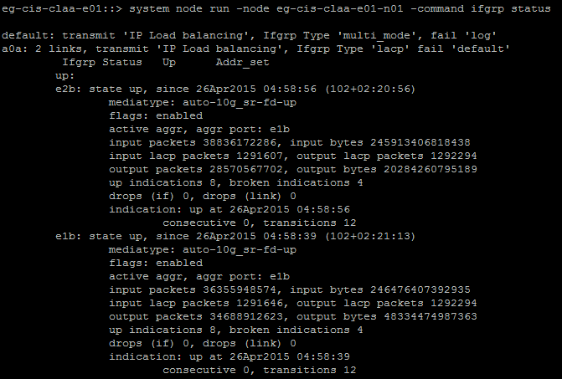

- Revert all the failed over LIFs to its parent node

Once network team confirms the configuration and ifgrp status is good, proceed with revert all the LIF to its home node.

Run “network interface revert *” and you will getting the status like below

eg-cis-claa-e01::> network interface revert *
25 entries were acted on.

eg-cis-claa-e01::>

- Check the node’s event/message log regarding the LIF revert
- Check the node network configuration on Node 1

Check the network interface based on protocol on Node 1.

Run “network interface show -data-protocol nfs|iscsi|fcp -curr-node eg-cis-claa-e01-n01”

The output should displays all the LIFs for Node 1 and the Home value is True.

Or

Run “network interface show” from cluster console. The output displays all the LIFs for both the nodes and the Home value is True

- Do the same procedure for Node 2.

